Wednesday, May 20, 2020
Flight 20
Short, inconclusive flight due to wind and possibly (I’m assuming) the incorrect horizon discovered prior to flight 22.
Flight 21
Short, inconclusive flight due to wind and possibly (I’m assuming) the incorrect horizon discovered prior to flight 22.

Friday, May 22, 2020
Flight 22:
This was problematic. For whatever reason, the aircraft’s horizon was very wrong. Most significantly, the aircraft wanted to pitch up about 10 degrees. This explains why I’ve had to make constant trim adjustment over the past few weeks. Not sure why this happened, but I’m going to have to keep an eye out for it to come back. I never really got off the ground before realizing there was an issue.
Flight 23:
Good flight. After resetting the horizon and re-calibrating the accelerometer (not sure why I had to do that), I took off in a hover and hover-flew around in a nice little circle. I flew it “forwards” like an airplane, but in multicopter mode.
Flight 24: First Transition Test
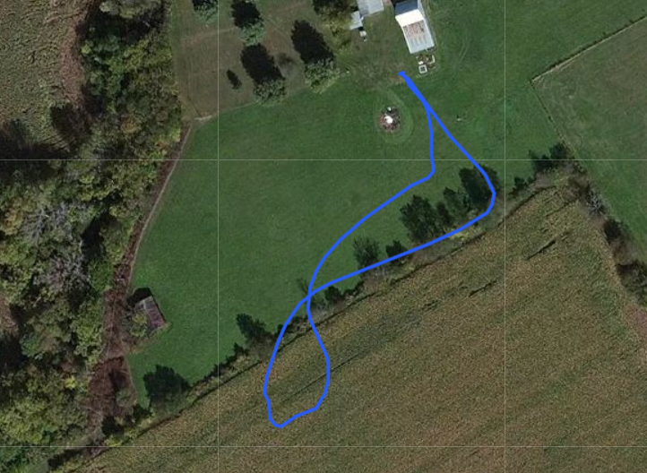
Position data from the test flight. Note that these are outdated satellite images, and the obstructions it looks like I flew over (the tree line and burn pile) are actually gone.
This test consisted of two different transition attempts. One outbound, and the other inbound. In both situations, it sounded like one of the forward propellers was interfering with the fuselage during the transition. I’m not sure why. Also, it looked like the fuselage was at an angle (with respect to the longitudinal axis) during the transition. This could perhaps be related to the previous problem, but it’s not clear to me yet.
After this flight, I noticed the right front motor pivot had slipped. Because of the mark I made on the pivot axis, it seemed to be a slip in the belt that had caused it. As a temporary fix, I just slipped the belt back to where it should be. I need to continue to watch this to make sure that is the actual failure mode. I could look at using 3d-printer belt tensioners (which are spring-based) to help mitigate this problem, but it’s not yet clear if that would be sufficient.
After this test, I cut off the part of the fuselage (front right tip) that seemed like it was interfering with the right front motor.
Flight 25: Second Transition Test
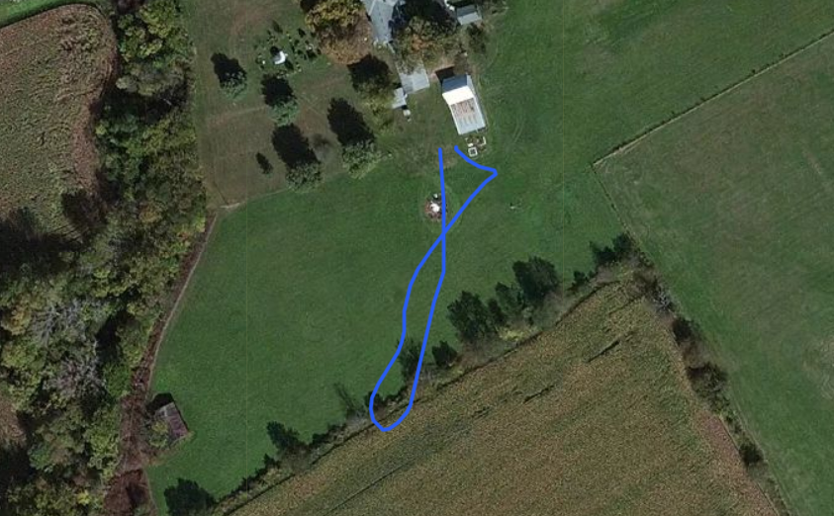
The Problems during this test were almost identical to those experienced during both attempts during the previous test. That said, I will say that I am very impressed by the hover controller. I won’t dare say it’s perfect, but I’m impressed that it stabilized the aircraft in both of these flights. Also it felt really good during the final descent, decceleration, and landing. Coming in, it looked just like you would expect a VTOL aircraft to look (in a movie or something).

After these flights, I looked at the flight logs. It’s not entirely clear what happened, but

Saturday, May 23, 2020
Flight 26:
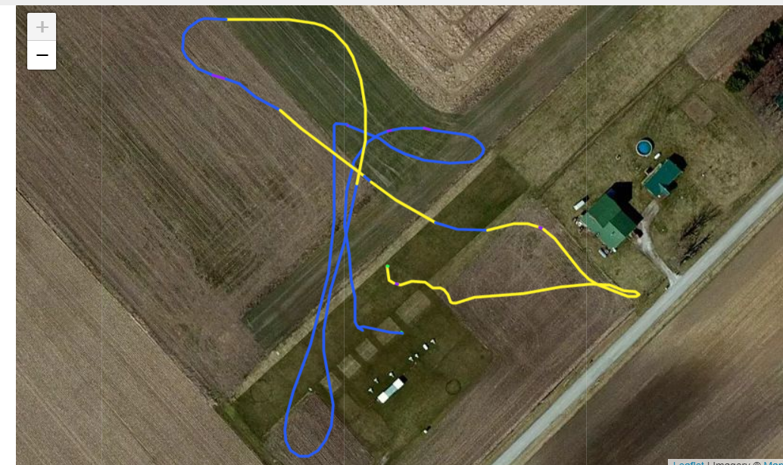
Position Data from the flight. The Blue line represents flight in Stabilized mode, the yellow line is flight in Position mode. The map may be a little off, as I thought that I got closer to that barn than shown in this image. Regardless, it was uncomfortable.
This flight took place at the flying field in Wilmington, OH (Clinton Model Aviators). The plane exhibited some similar behavior to what I experienced during yesterday’s flights. For example, the tail still did something weird. It’s not clear to me at the moment whether or not the propellers interfered with the fuselage during the flight. I would love to put a small action camera on it (to see what’s going on), but the polaroid cube I purchased a few days ago is refusing to charge.
However, a few other things went wrong:
- Despite reaching ~18.8 m/s in horizontal flight, it did not complete a transition (it went into transition mode, in which it does a partial transition, but it would not finish). My ground-testing previously showed that the aircraft would not complete a transition (with the motors spinning) on the ground, but would finish transition if I cut the throttle for a moment. I wasn’t sure if it would work, but I tried gliding at least once during my transition attempts during this flight. It didn’t, but I suspect that’s because the aircraft was looking for an airspeed sensor, which it couldn’t find. I own a pitot tube airspeed sensor, but I just found out a few days ago that it does not work. Fabulous. I don’t know if it’ll fix my issue, but I figure I might as well try using FW_ARSP_MODE to disable use of the airspeed sensor. It’s worth a shot.
On the note of gliding, I will point out that when I cut the motors, it honestly did a pretty good job of gliding in a controlled fashion. Probably shouldn’t be a surprise, but it’s validation that the aircraft won’t arbitrarily stop flying when finally I get into forward flight mode (assuming the motor-mounting arms can take the forward thrust.
At this point in the flight, I thought maybe I should try putting it into manual mode because I thought the aircraft might just allow me to take manual control and do whatever I needed to do (in fixed-wing mode).
- I did not realize it in-flight, but hitting the “flight mode” switch on my transmitter (this is actually a setting on the flight controller) selected between the following options:
  - Stabilized mode - The mode I use to take off in multicopter mode
  - Position Mode - In multicopter mode, this attempts to hover in one position. Control inputs coorespond to movement commands. It’s not clear to me what happens when you try to switch into this mode during a VTOL transition to fixed-wing mode.
It’s not clear to me if that’s how it was set up before the flight, but I believe it defaulted to position mode because manual mode isn’t really a thing for a multicopter (because remember, the aircraft was still half-multicopter at this point in the flight). Regardless of which mode that switch was actually set to activate, it would not let me take off (in multicopter mode) ahead of the flight. Eventually, accidentally switching to position mode caused some really uncomfortable situations (and could have caused a crash if I hadn’t put it back into stabilized mode), including accidentally hovering over a nearby barn.
- I accidentally ended up landing in position mode. It was weird, and I didn’t know what was happening initially. Despite a ridiculously low throttle setting, the aircraft descended very reluctantly and finally set down.
- The pixhawk reported signal lost a several times in-flight. This has actually been the case during a lot of these test flights, and it’s making me a little nervous. I was under the impression that satellite receivers were full-range, but maybe that’s not holding up. Or maybe it’s because the receiver is so close to the battery, which is pumping a fair amount current. Maybe I should investigate moving the receiver or finding out whether I can put multiple satellite receivers in parallel (it’s a serial connection).
Now for what went right during the flight:
- All things considered, the aircraft is doing a pretty darn good job keeping itself in the air. This is despite me accidentally putting it into position mode while it’s awkwardly trying to transition from being an over-bloated quadcopter to a crappy airplane. Plus whatever seems to be going on with the tail.
- The aircraft glided remarkably well when I shut off the motors mid-transition. That isn’t to suggest that it’s gliding efficiently (look at it. There’s NO way). I’m just suggesting that when I get it into FW mode, that it’ll be alright.
- Recovered from multiple potentially-hairy situations.
- On top of points 1 & 3, the aircraft really feels pretty good in a hover. Taking off felt really smooth. Natural, even.
Monday, May 25, 2020
Flight 27: First Successful Transition
Here's what I changed before the flight:
- Changed FW_ARSP_MODE to disable use of the airspeed sensor.
- Cut off the aft-most tip on the rudder (it came to a tip near the top) because I thought that could have something to do with the twisting I have seen in the tail during transition tests.
- Decreased the parameter that sets the open-loop (meaning you have no pitot tube airspeed sensor) transition time from 4.5 seconds to 4 seconds. This is not the first time I’ve arbitrarily adjusted this number, but it never really counted before because it never finished a transition. The reason I decreased it this time was just in case it being a large-ish number was the reason I had never experienced a full transition. That is, to say I had never waited long enough. I was pretty sure this was not the case, but because I had never measured my transition times in the data, I went for it anyway.
- Adjusted the rudder output trim because the rudder wasn't perfectly centered. This also could be related to the tail twisting.
The flight went very well. Spent the last 20 seconds of cruise (while climbing) at about 13 m/s ground speed. During the outbound transition, I noticed that the aircraft wanted to yaw to the left pretty hard. It looked like it was trying to turn to the left. Of course that meant it was fighting it's own aerodynamics pretty hard. I'm not sure why this was the case, but a little right yaw input helped it straighten out. Also strange is the fact that the aircraft flight log shows the aircraft facing mostly southward and trying to fly the transition towards the west or southwest. After the transition is complete, and the aircraft is flying in fixed-wing mode, the data straightens out. I do think there was some of this “scrubbing” phenomenon in the flight, but it looks exaggerated in the data. I’m not really sure what’s going on here, but it could be a sign of a compass or gyro problem… combined with just poor flying.
This was an intentionally short flight (I wanted to try a back-transition asap), so I didn't try switching into manual mode or really exploring the performance of the aircraft. Not that it matters MUCH on this airframe anyway.
Now that this plane has done a successful transition, I’m thinking about things I'd like to do next. The only issue is this plane is not holding up very well, and it likely has a limited number of flights left.
Things I’d like to do next:
- Fly again and put it into manual mode during cruise.
- Get the rpm sensors saving data and get them installed.
Optional things I could explore
- Autonomous fixed wing flight
- Autonomous hover flight
- Autonomous VTOL flight with transition
- Flying with spoilerons instead of a rudder or v-tail. Not yet sure if this is possible, but this was one of the original goals of this project.

